Project Development Phase
Performance Test

Date | 30 September 2026
Team ID | SWTID-2026-9545
Project Name | Import Data using Transform Maps (Spreadsheet) – ServiceNow
Maximum Marks

Functional and Performance Testing:
Project team shall fill the following information in the performance testing template.
S.No. | Parameter | Values | Screenshot
1 | Summary | ServiceNow automation for employee data management using Import Sets, a Transform Map with coalesce, custom table u_employee_test, three reports and a dashboard. Note: if source data matches the map correctly, records are created; otherwise the import log shows errors. | 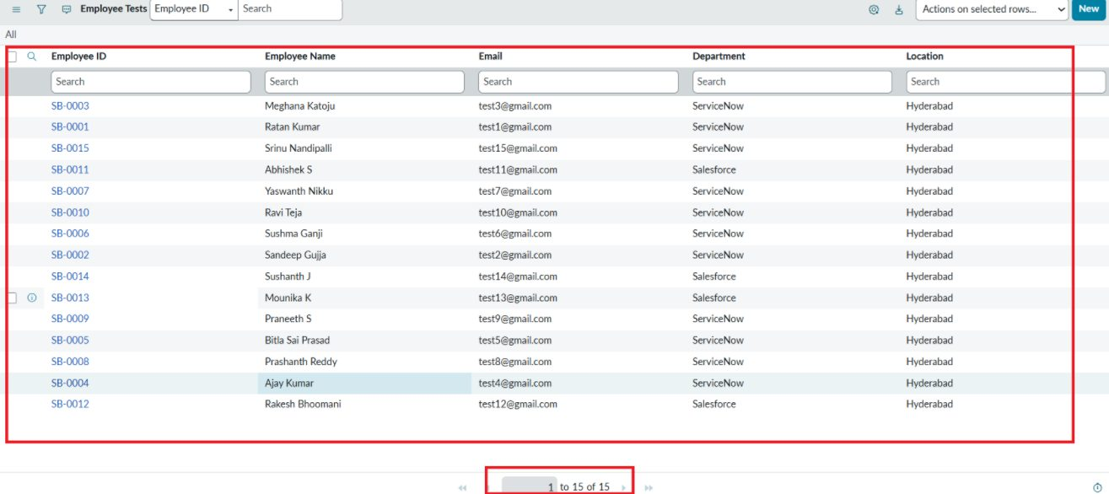
2 | Initial Load (Import Set) | Processed: 15, Inserts: 15, Updates: 0, Errors: 0, Empty/Ignored: 0. State: Complete, Completion code: Success. Time: 1.368 s. | 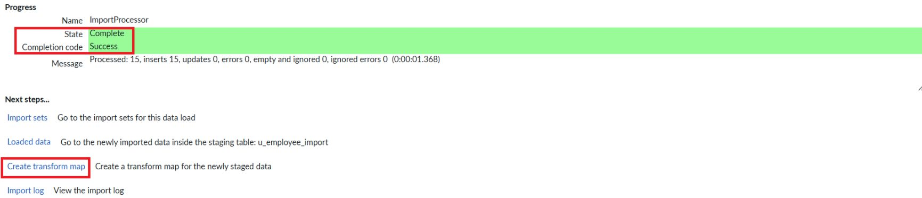
3 | Initial Transform | Transformation complete: State Complete, Completion code Success. 15 records created in Employee Test. | 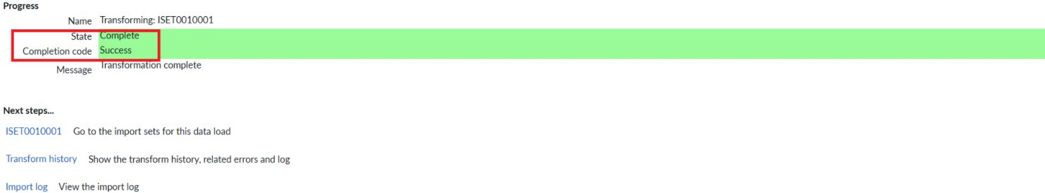
4 | Re-import with changes (Coalesce = Employee ID) | Total: 4, Inserts: 2, Updates: 2, Ignored: 0, Skipped: 0, Errors: 0. Run time: 1 second. | 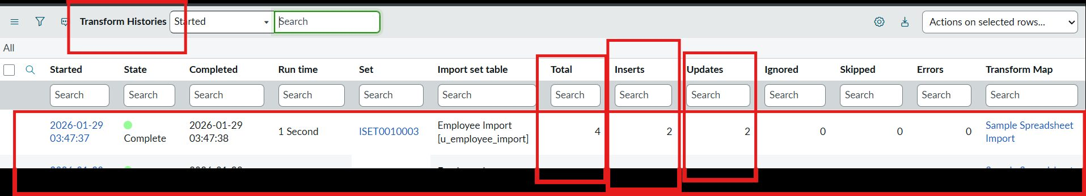
5 | Repeat import of same sheet | Total: 4, Inserts: 0, Updates: 0, Ignored: 4, Errors: 0. Run time: 0 seconds – no duplicates created. | 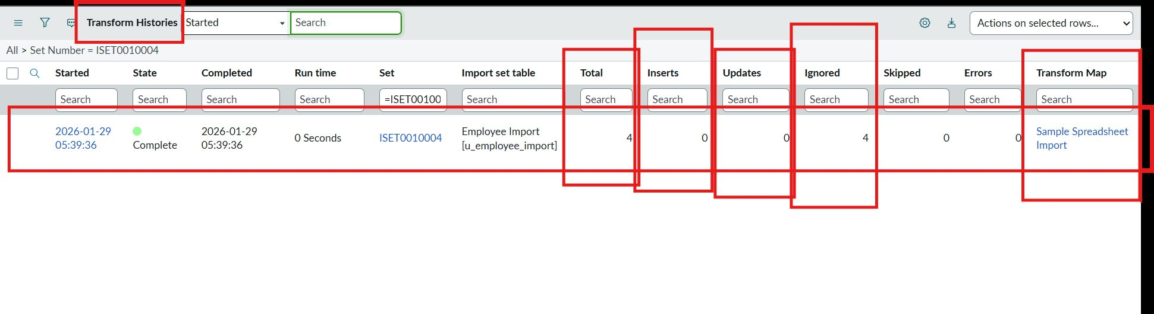
6 | Data Accuracy | Record success rate = records processed without error ÷ total records = 15/15, 4/4 and 4/4 = 100%. Final table holds 17 unique Employee IDs (SB-0001 to SB-0017). | 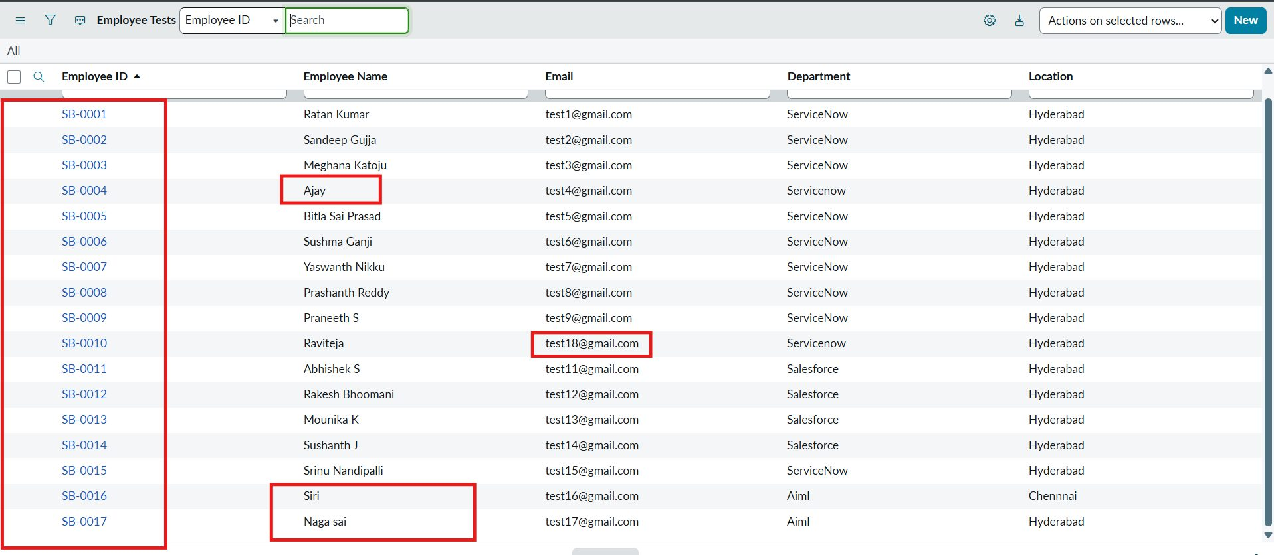
7 | Reports and Dashboard | 3 reports (Pie, Bar, List) and 1 dashboard rendering 17 records: ServiceNow 11 (64.71%), Salesforce 4 (23.53%), AIML 2 (11.76%); Hyderabad 16, Chennai 1. | 